**The University of Arizona**

**College of Applied Science and Technology**

**CSCV 471. Artificial Intelligence**

**Homework Assignment 2. Search Techniques**

# Objectives

* *Understand the search techniques to solve real-world problems*
* *Analyze the blind-search technique*
* *Analyze the heuristic search*
* *Analyze the greedy-search algorithm*
* *Analyze the adversarial search*

# Instructions

You must formulate a blind-search technique solution in *Python*. You need to give the initial state, goal test, successor function, and cost function to formulate this problem:

*You need to show to the user how to color the USA map using only four colors, with no two adjacent states having the same color (see Figure 1 to see an example)*

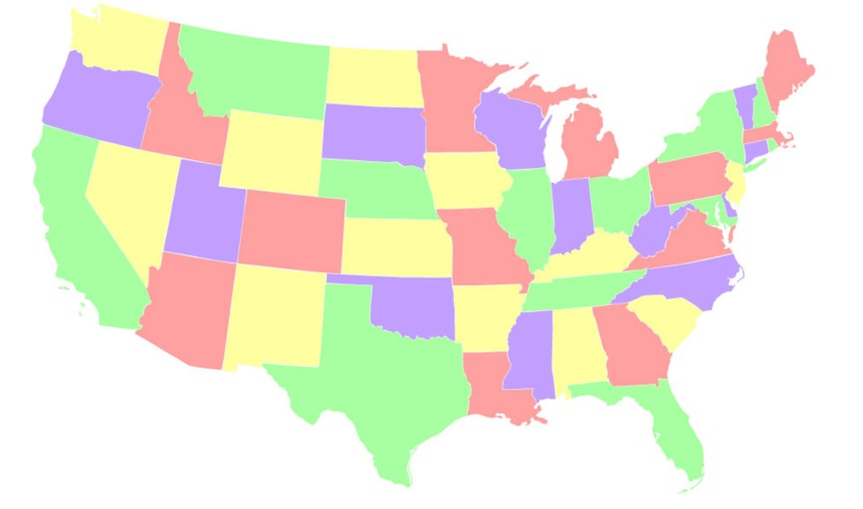

***Figure 1****. USA map colored using the Four Color Theorem*

There are several forms your output could take. It could be in text form, like this:



***Figure 2****. Text-based output*

Using matplotlib, you could generate a map like this:

***Figure 3****. Output produced with matplotlib*

**Note:** Creating output with a geographically correct map, such as in **Figure 1** above, is the best solution. However, it requires additional advanced Python libraries, as well as providing map files. I do not expect you to produce such output unless you are an advanced Python programmer and comfortable doing so. Similar output to **Figure 2** or **Figure 3** is sufficient (although yours should include all 50 states – I have only included a sample of states in these examples).

# Additional Instructions

I want you to use freely available AI tools to assist with your analysis of the problem, as well as with writing the code. ChatGPT is a good tool and there are other code-writing tools that you may find online (use Google to search for AI code-writing tools).

In your Word document, make sure you explain the formulation of your solution to the problem. Comment on why the blind-search technique is the best search algorithm for this problem, as opposed to the other search algorithms you learned about in this module. Describe which AI tool(s) you used to assist you in solving this problem. Describe how you used the tool(s) and what you learned from using AI to assist you in solving this problem. Address any challenges or obstacles you faced with using the AI tool(s) and how you solved them. If using ChatGPT, remember that you can ask it to explain the code it generates to you. Reflect on whether you feel using AI tools in this manner is beneficial to your pursuit of learning to code or if it is a hindrance, and why.

# Submission Instructions

Type your answers and submit in a word, or pdf document. It should have your name. What you submit should be your own work. Use APA format to complete this assignment, being sure to list all AI tools used*.* Also submit all code files you create. Put your code files inside of zip file and attach the zip file to your submission, along with your Word or PDF file.

# Grading Criteria

Total 70 points

1. Code Solution: 35 points
2. Written Reflections: 35 points